**Configure ELB and Autoscaling Lab – 3 of 3**

**Note: Before configure autoscaling group, you need to stop the all linux webservers.**

In EC2-Dashboard, click Launch configurations under “Auto Scaling”.

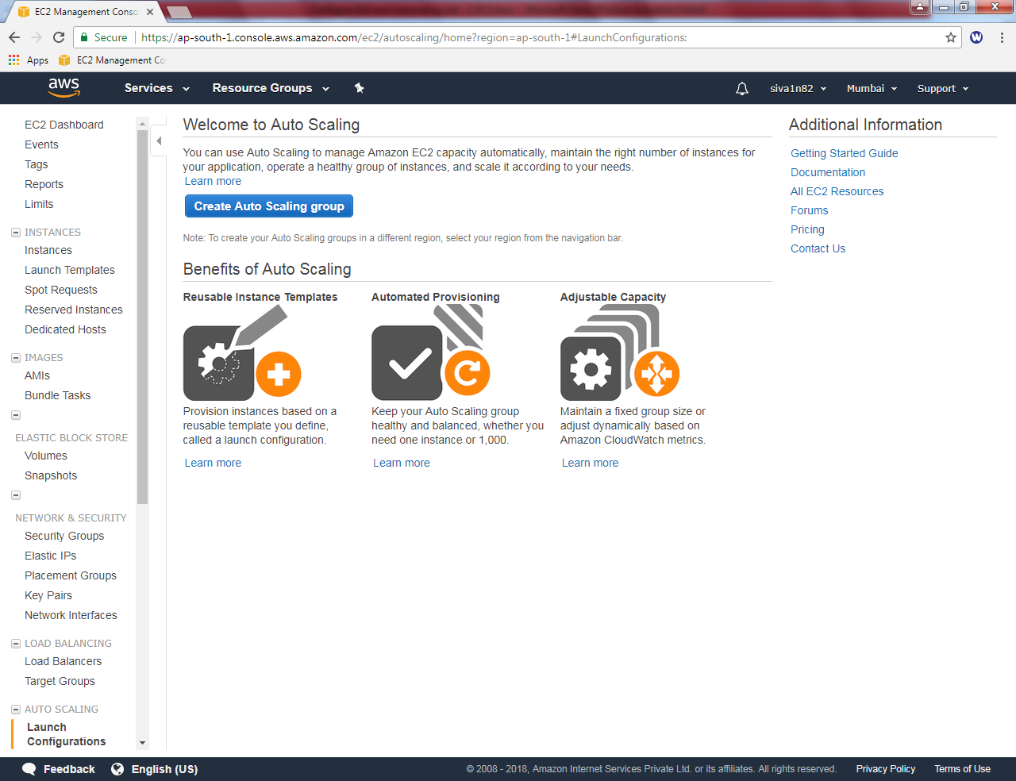

Click “create auto scaling group”.

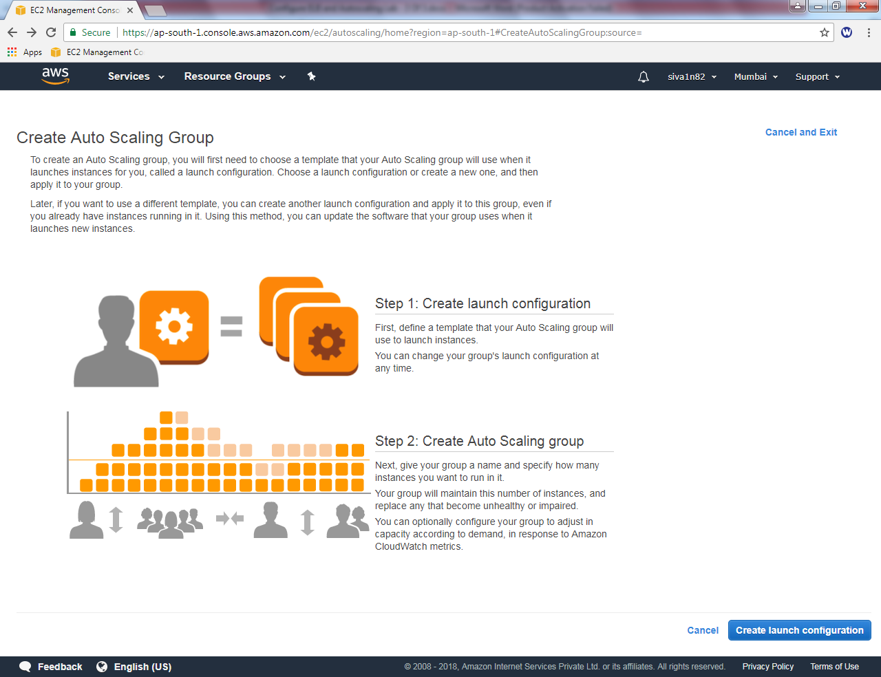

Click “Create Launch configuration”.

Click “My AMIs” and select

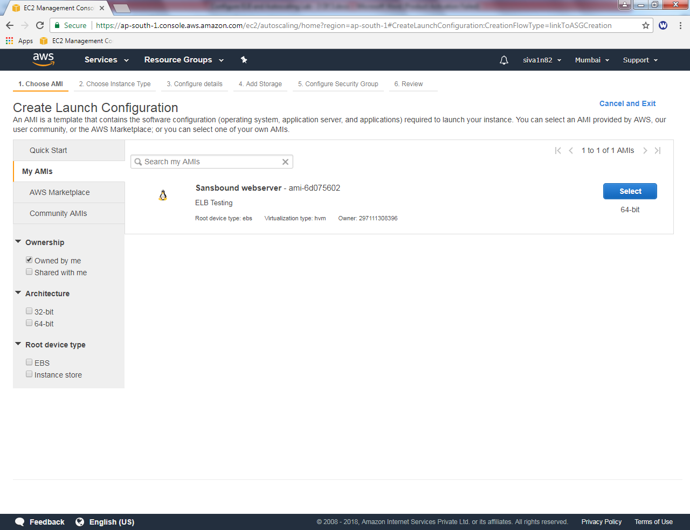

Select “t2.micro”

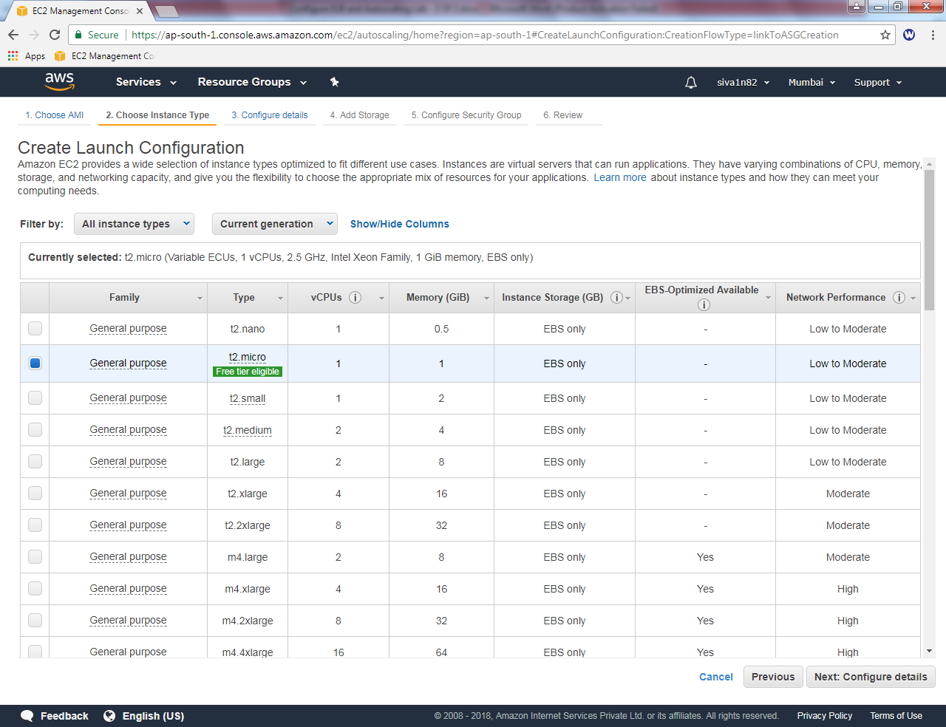

Click “Next”.

Create Launch Configuration,

Name : SansboundAutoscaling

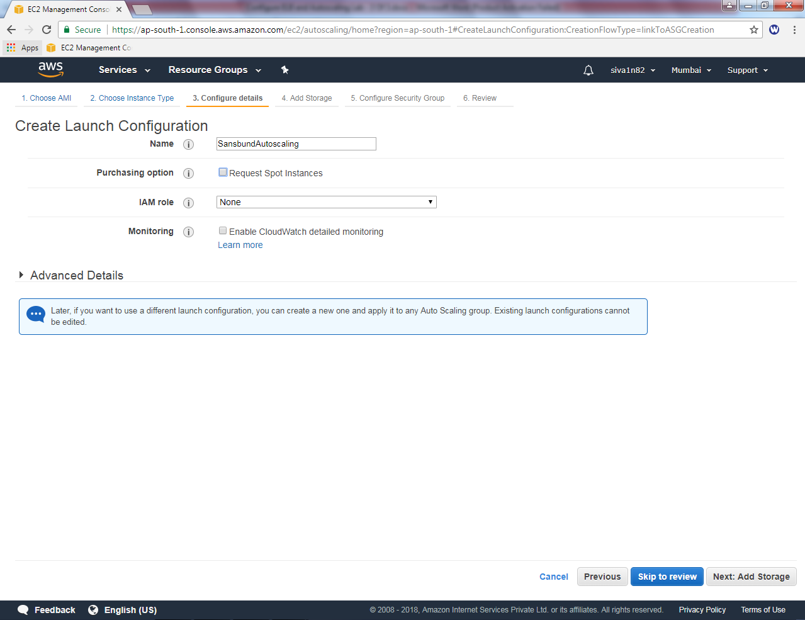

Click “Next”.

Leave settings as default and click ”Next”.

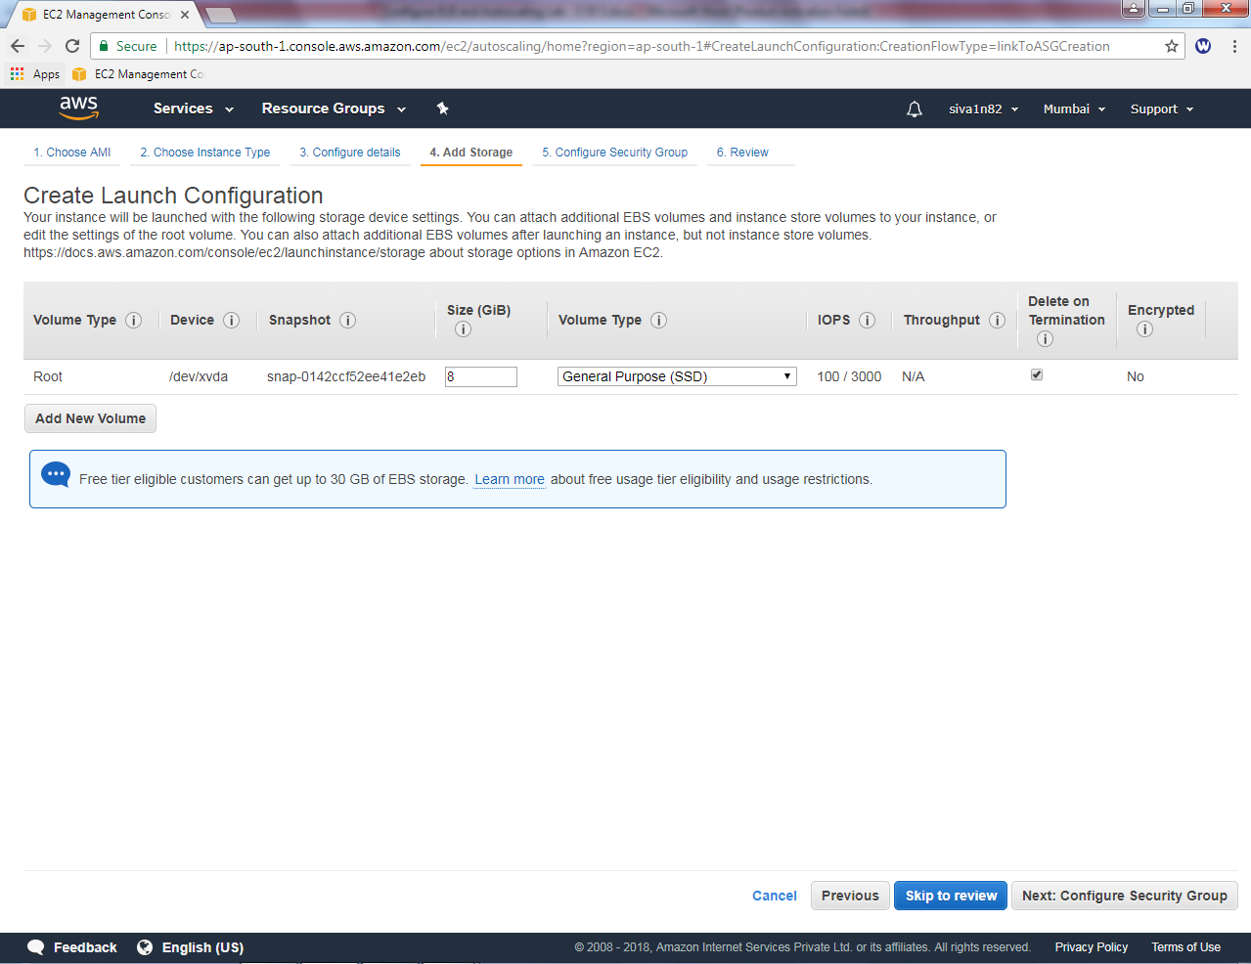

Select “ELB-Sec-Group”.

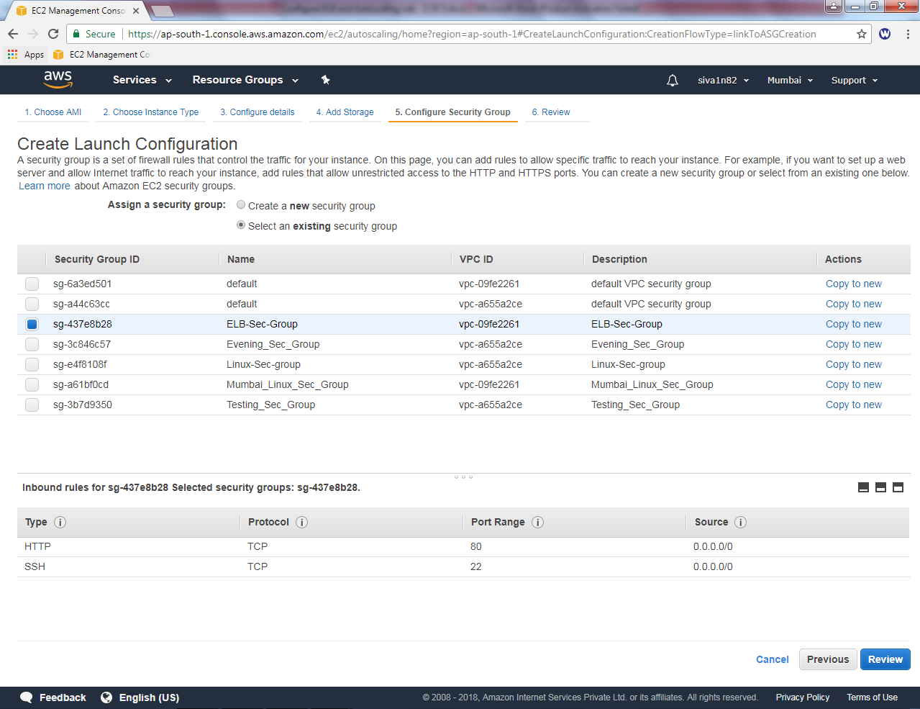

Click “Review”.

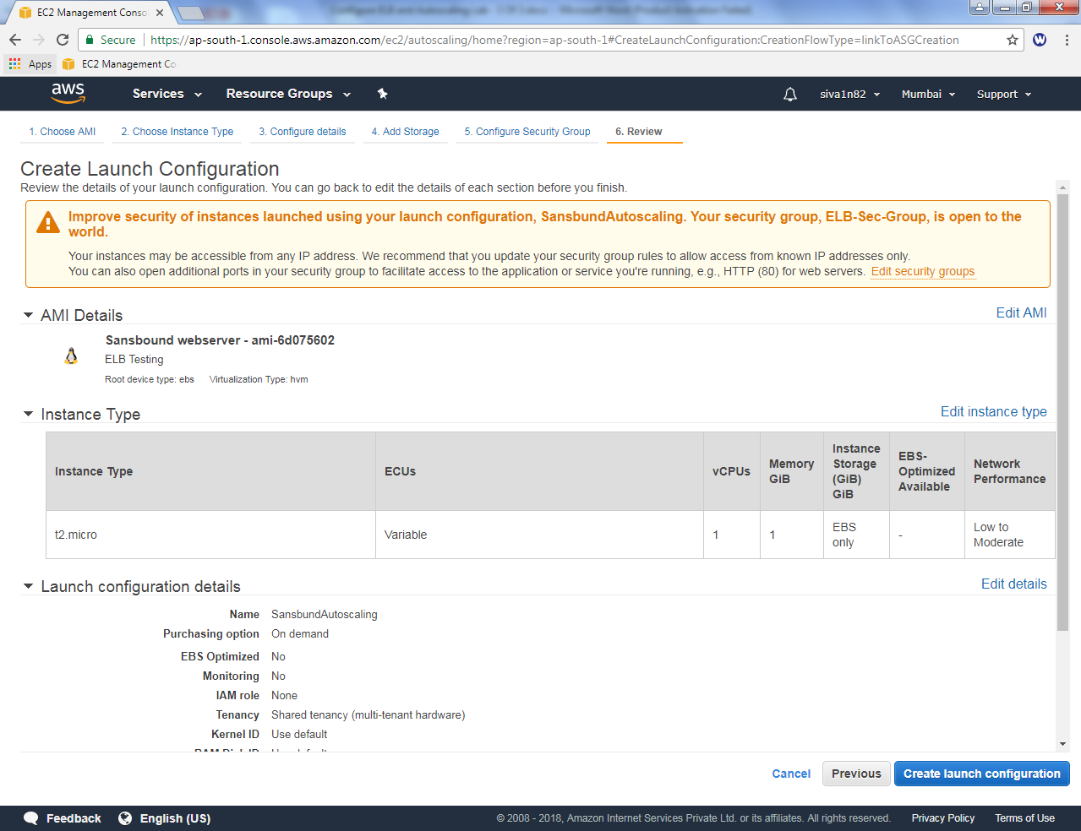

Click ”Create Launch configuration”.

While launch the instance, it asks select existing key pair or create a new key pair.

I will choose “Choose an existing key pair”.

Selecr the “siva_vpc” key pair.

Click “I acknowledge “check box.

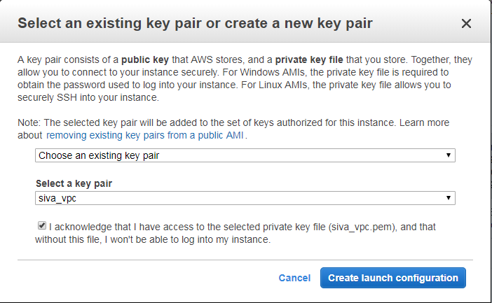

Click “create Launch configuration”.

Now it’s creating Auto scaling group,

Group name : Autoscaling

Group size : **2 instances**

Network : Select Sansbound_VPC_Mumbai

Subnet : **click the subnet box then only the subnet details will be shown**

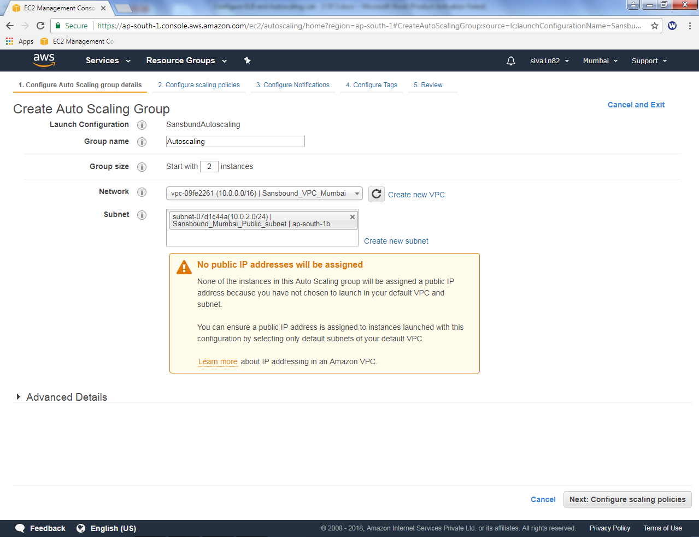

Click “Next”.

Select “Use scaling policies …..”

Scale between 2 and 6 instances (Mininum 2 and maximum 6 instances).

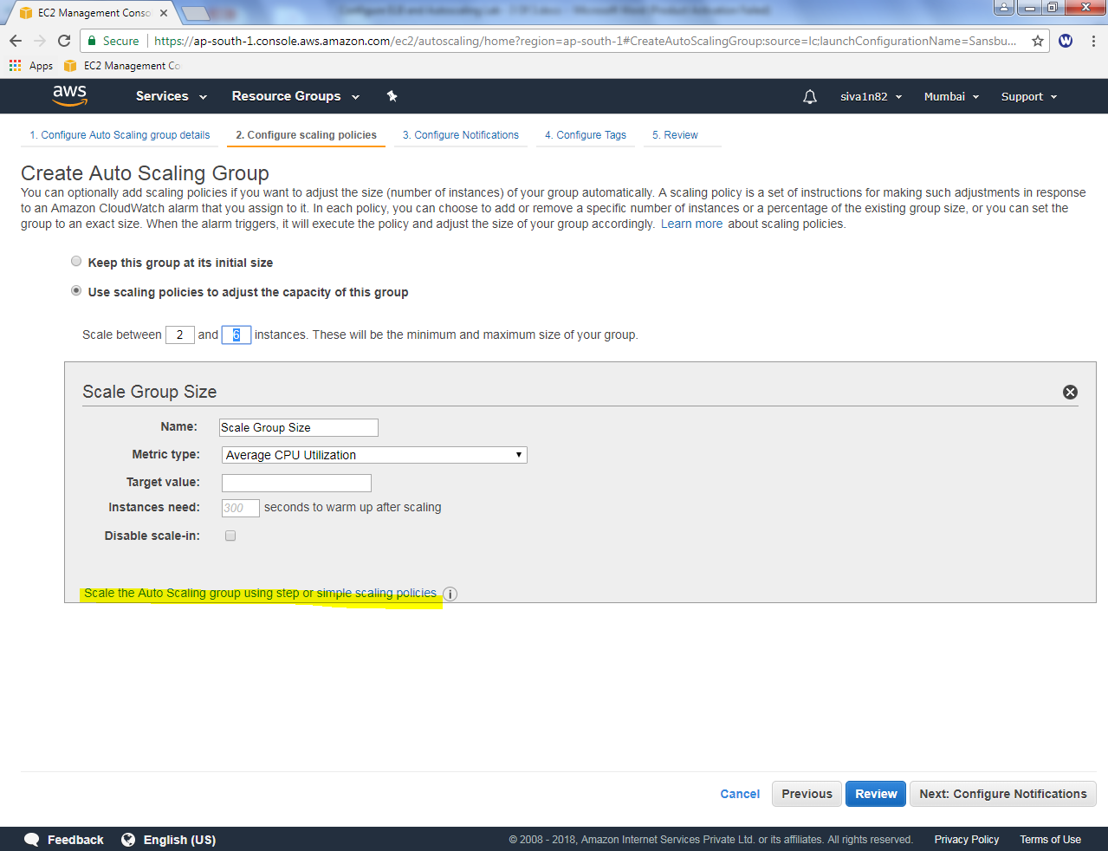

Click “Scale the auto scaling group using step or simple scaling policies”.

In Increase group size, click “**add new alarm”**

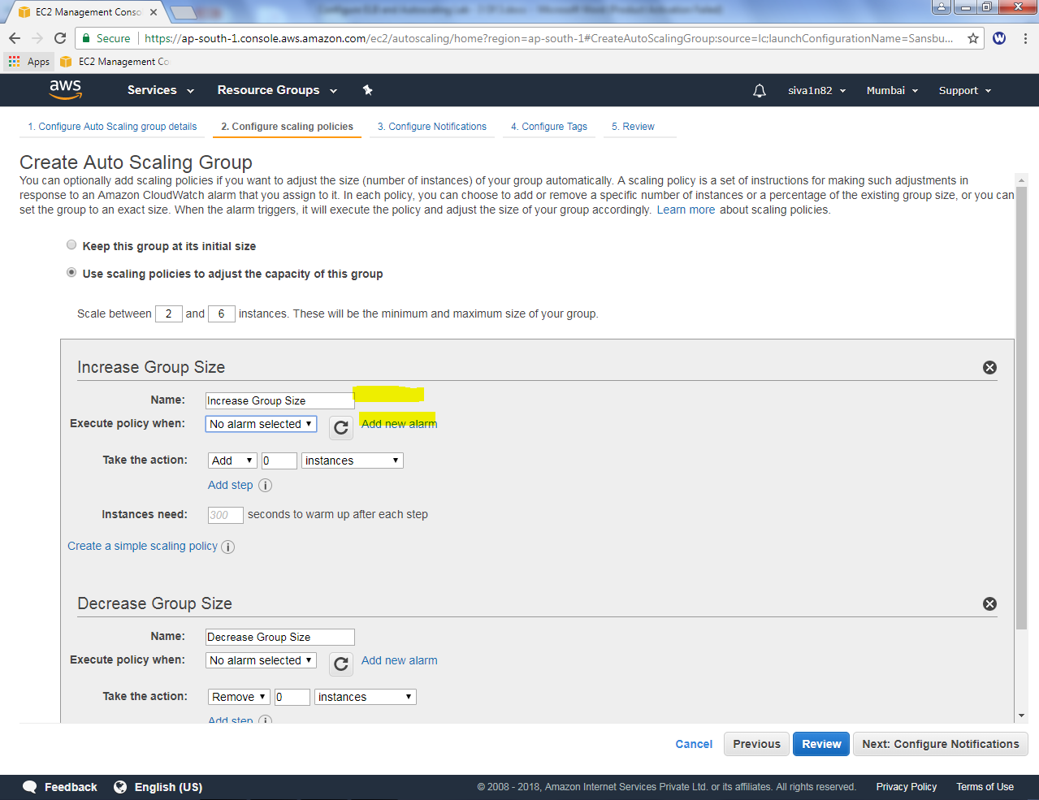

While creating alarm,

Uncheck the “send a notification to” checkbox.

When average of CPU utilization is >= 80 % one instance will be created.

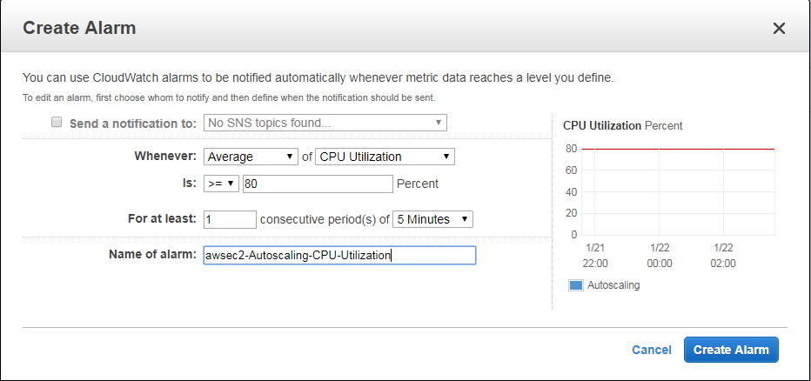

Click “Create Alarm”

In Decrease group size, click “**add new alarm”**

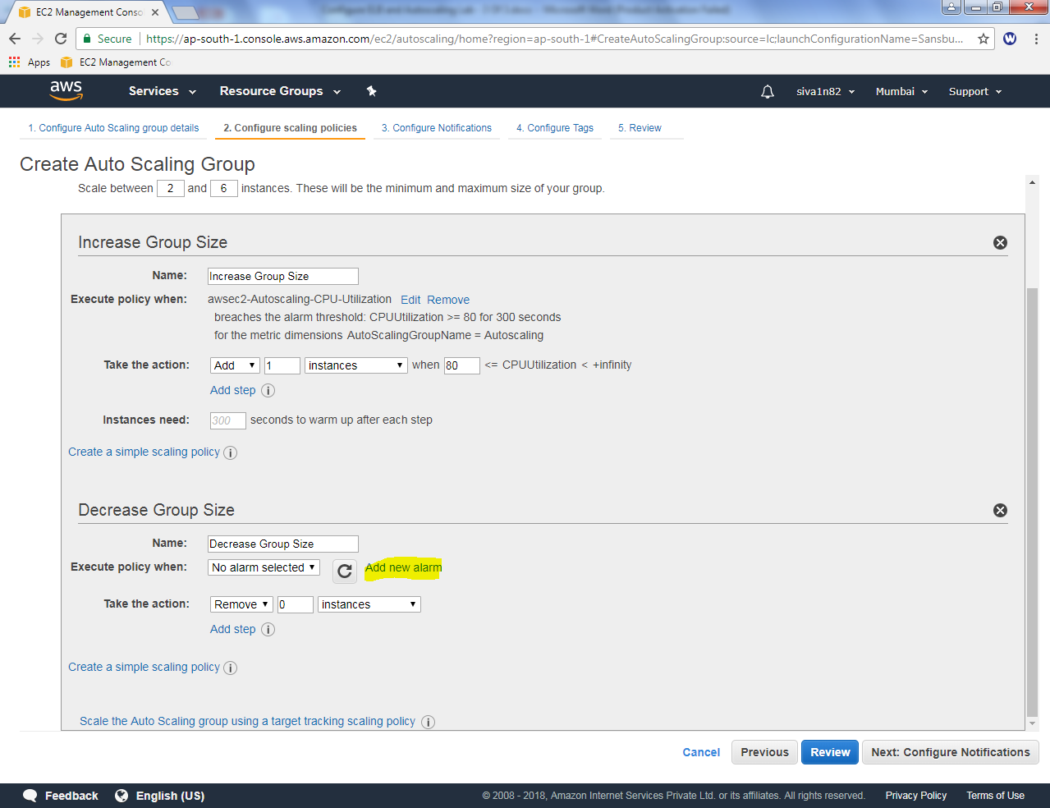

While creating alarm,

Uncheck the “send a notification to” checkbox.

When average of CPU utilization is <= 20 % one instance will be deleted.

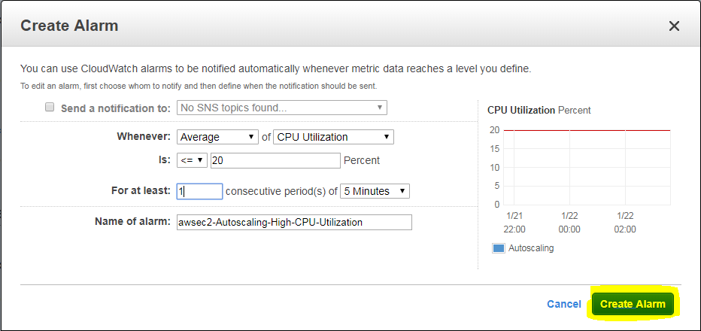

Click “Create Alarm”.

In Increase Group size

Add 1 instance when 80 %

Remove 1 instance when 20 %

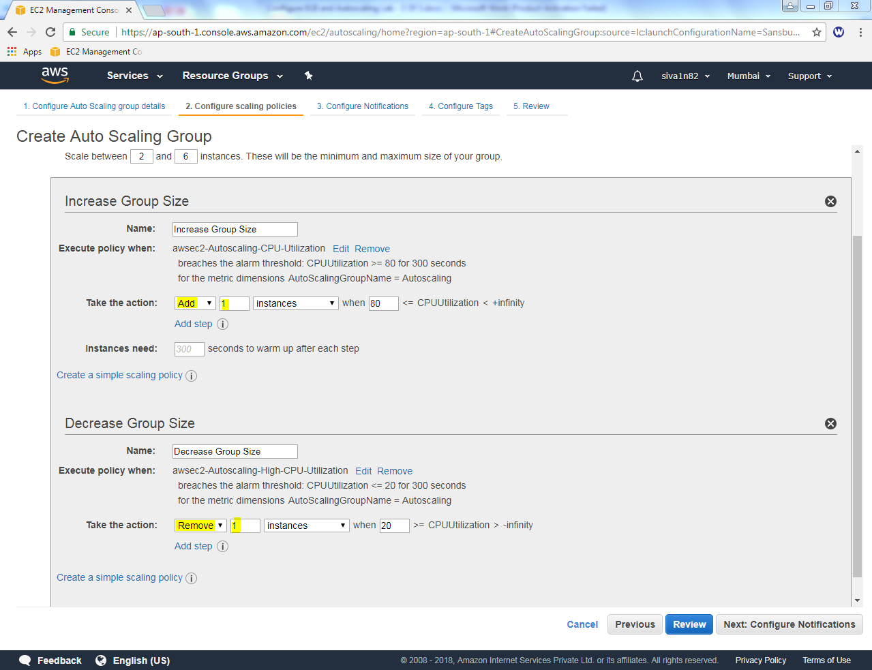

Click “Next”.

Leave default setting and click “Next”.

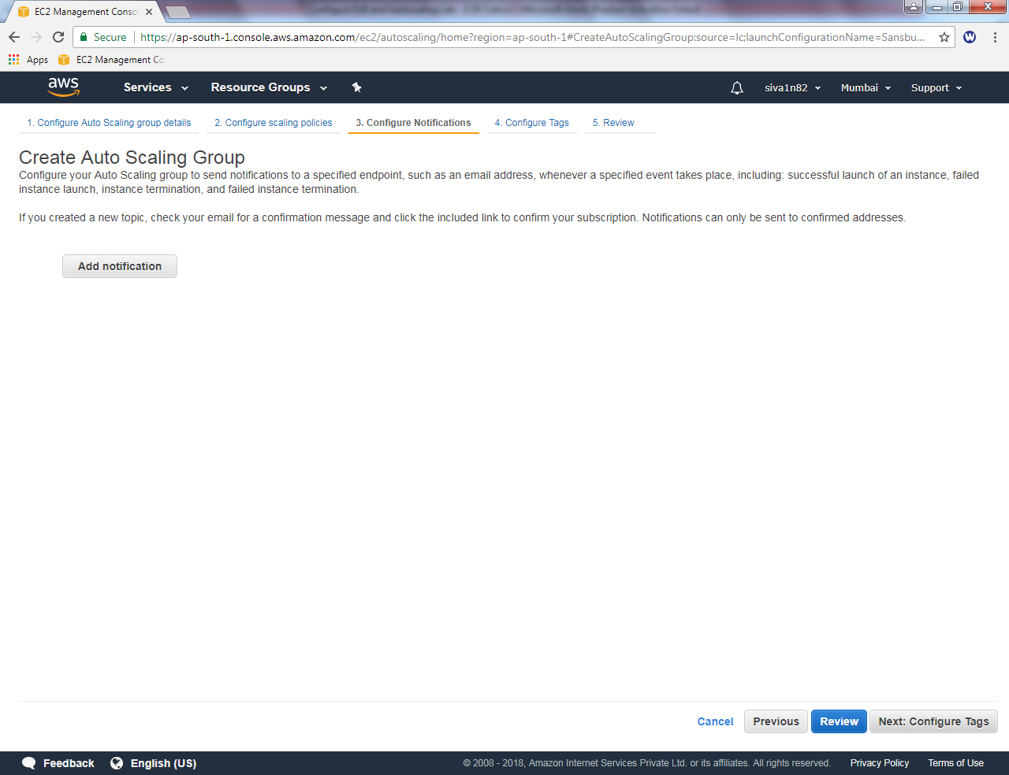

While creating auto scaling group, key as name and value as “Webserver”.

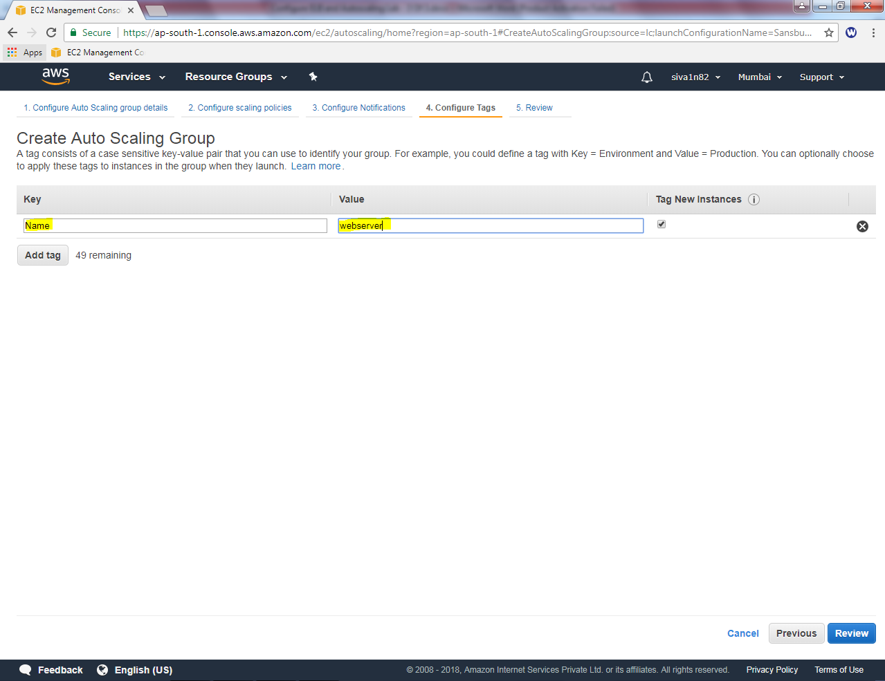

Click “Review”.

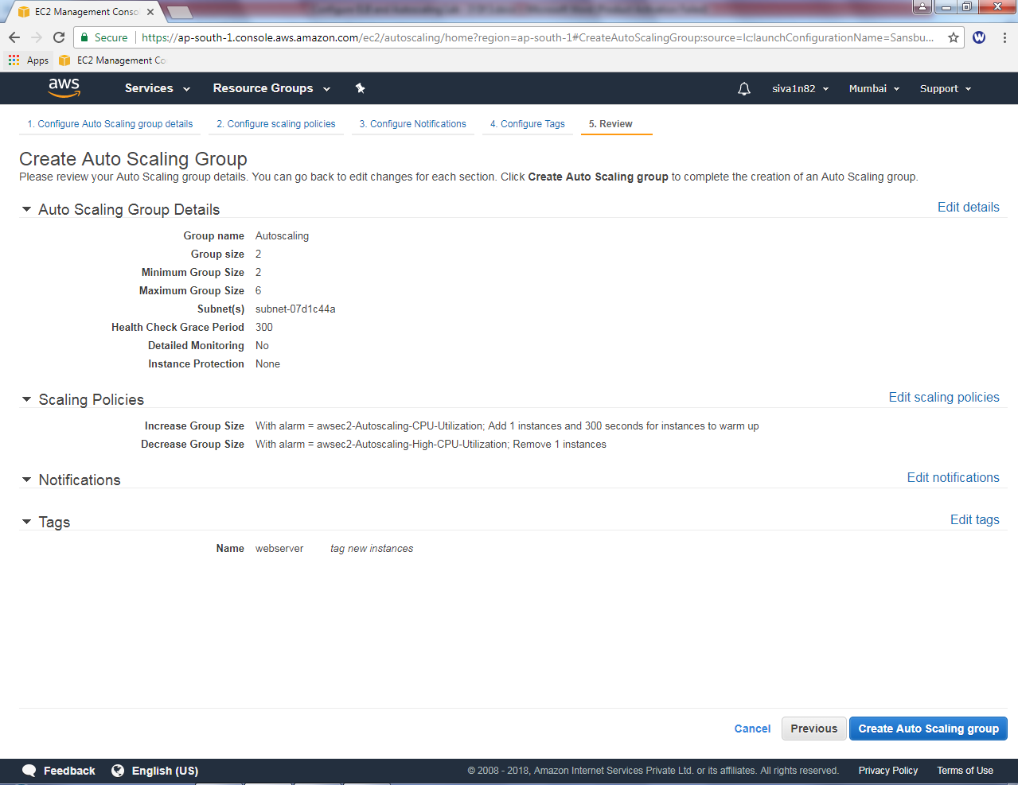

Click “Create Auto Scaling Group”.

Now the Auto scaling group has been created successfully.

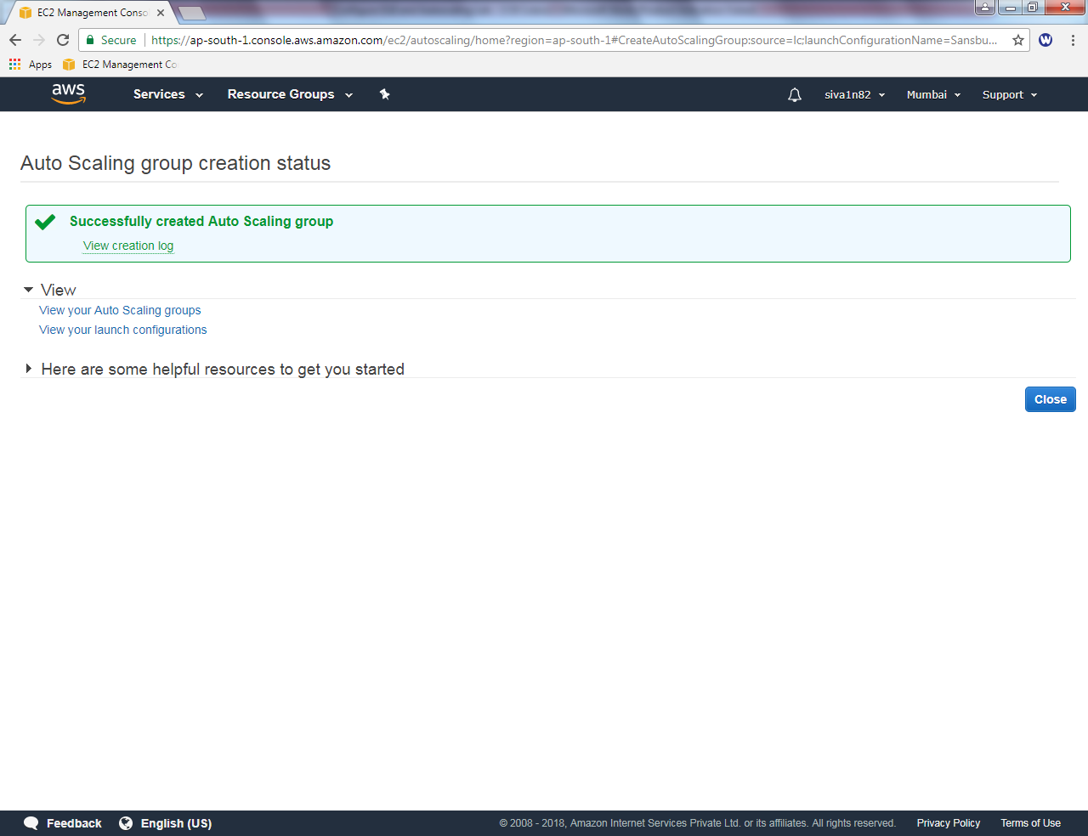

Now we able to see 2 instances are created by auto scaling group.

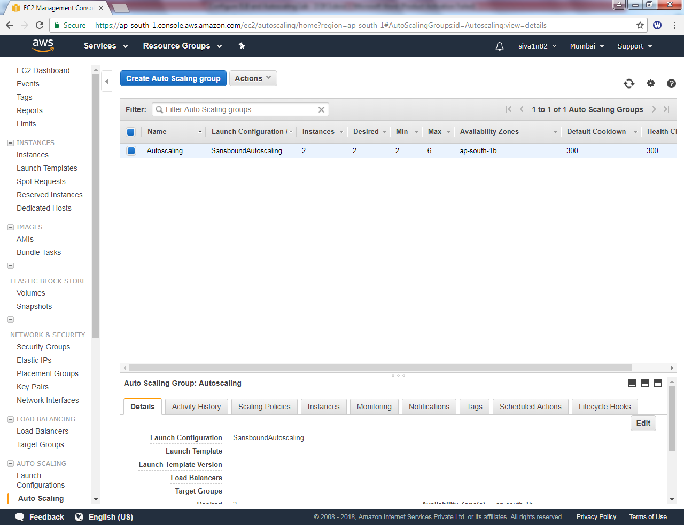

Click “Instances”, you can able to see that two instances in a initializing state. Please upto 2/2 status checks.

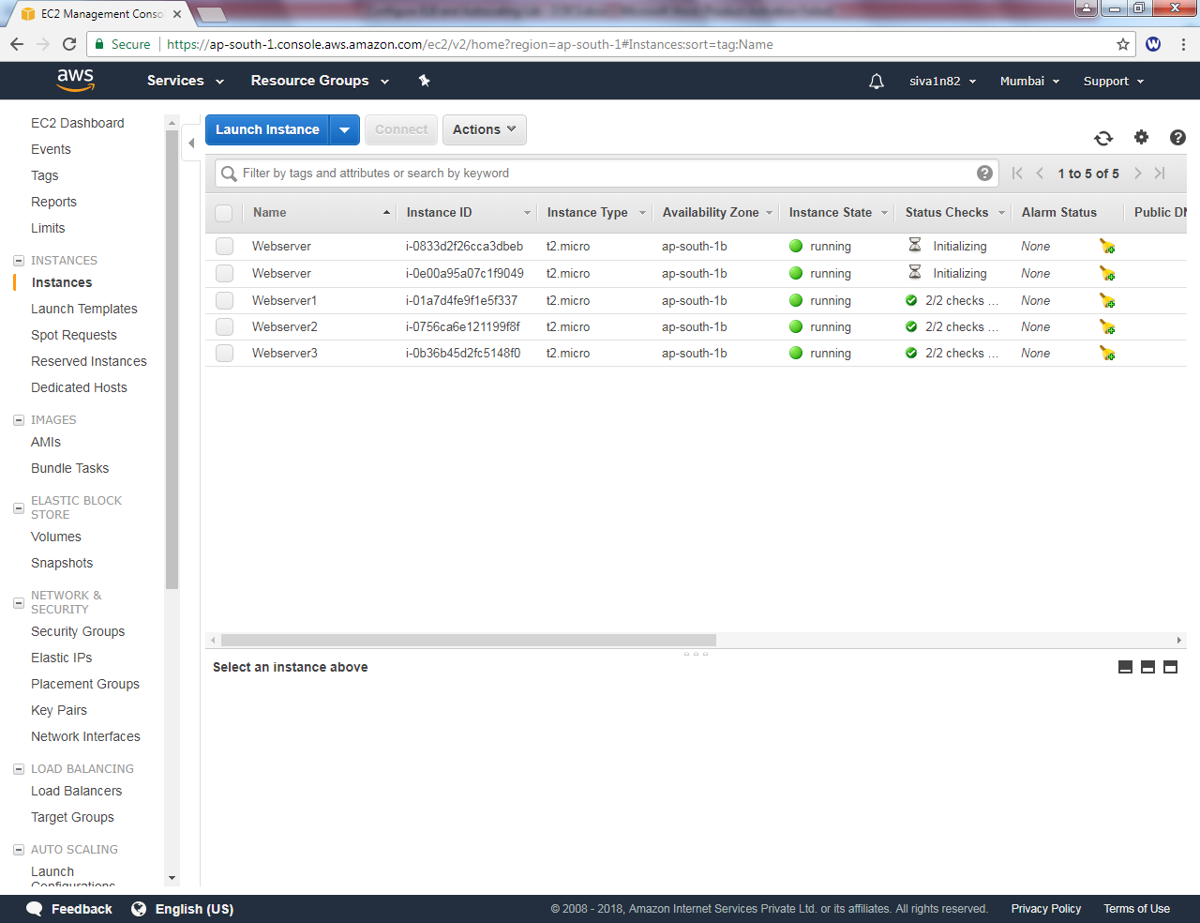

We can able to see 5 instances are in 2/2 status checks. Out of 5 servers only 2 servers are in Auto scale group which is in the name of “webserver”.

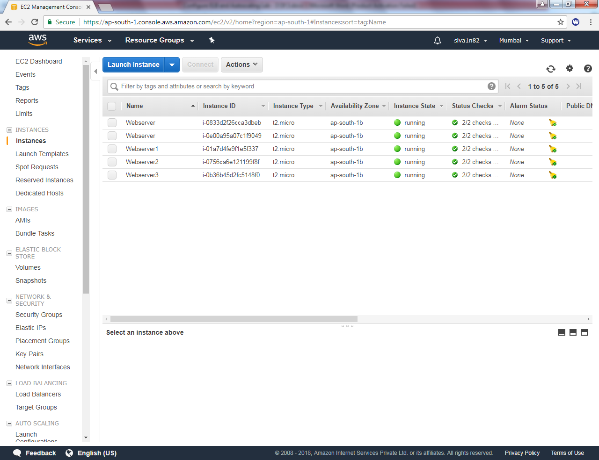

Select instance, Instance state 🡪 Stop.

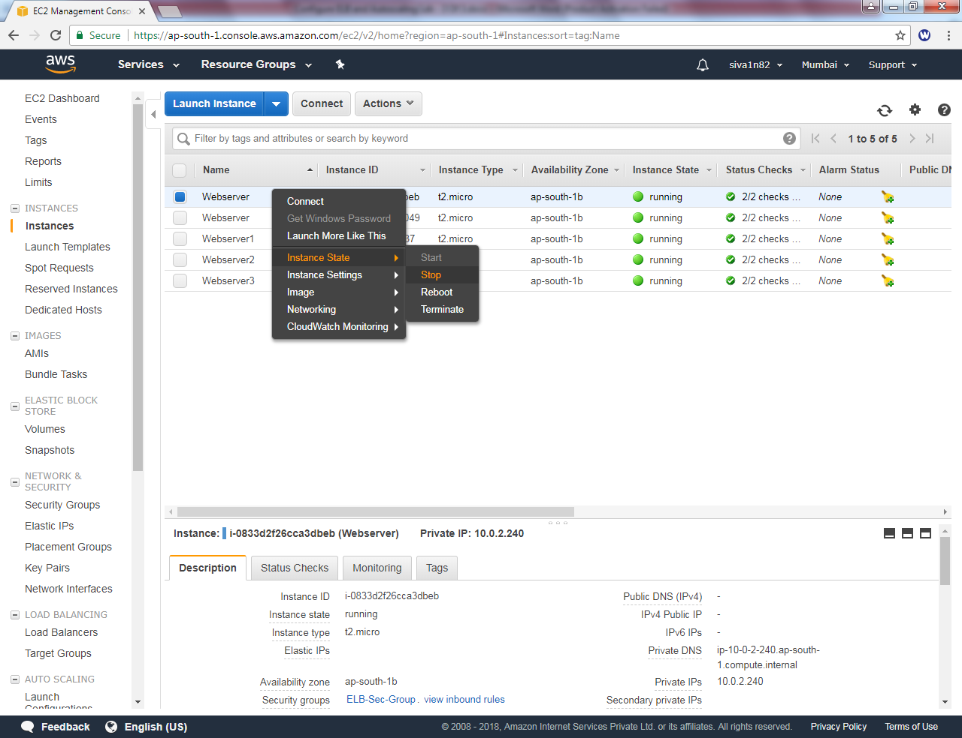

Click “Yes, stop”.

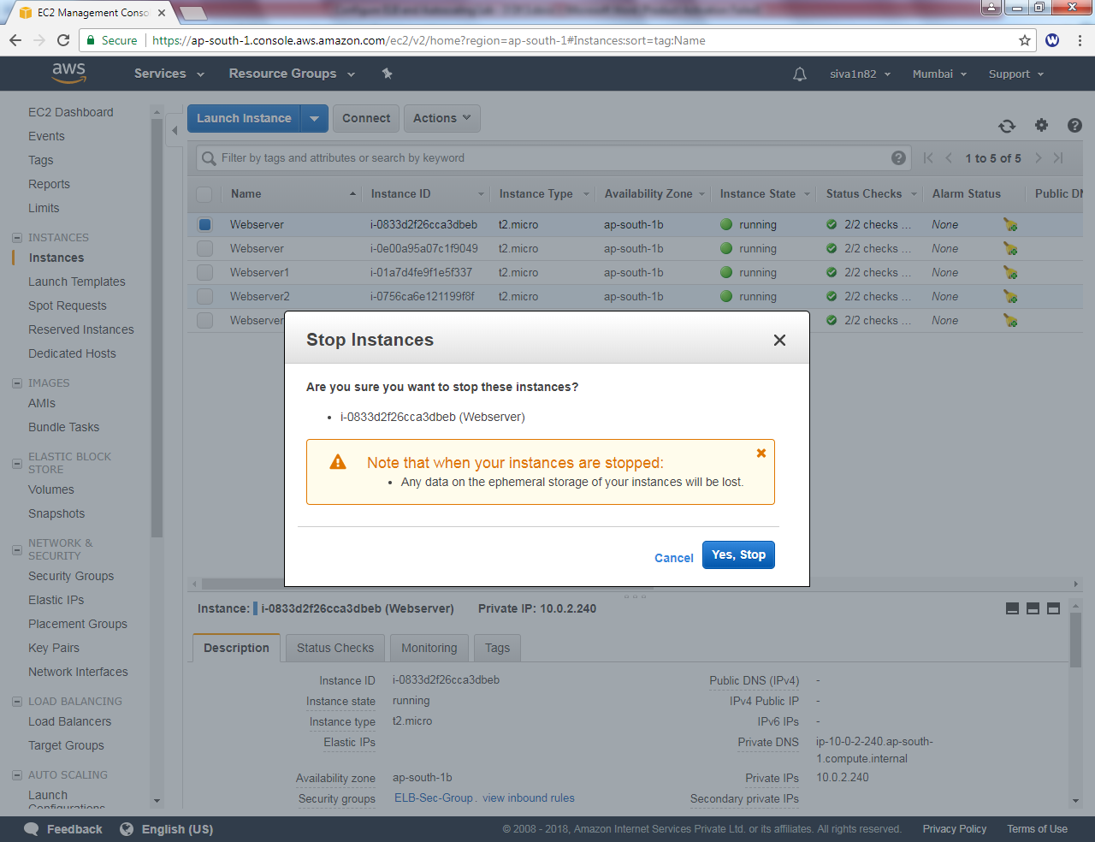

It’s getting “stop”

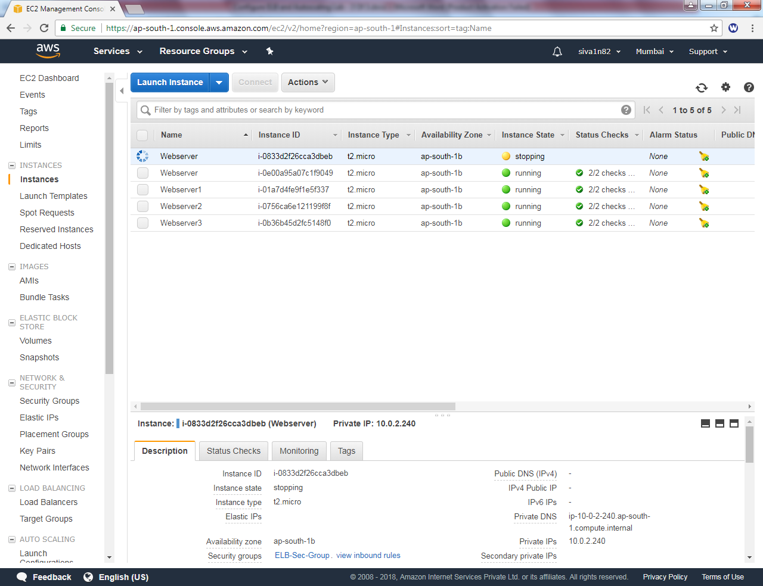

It’s in stopped state now.

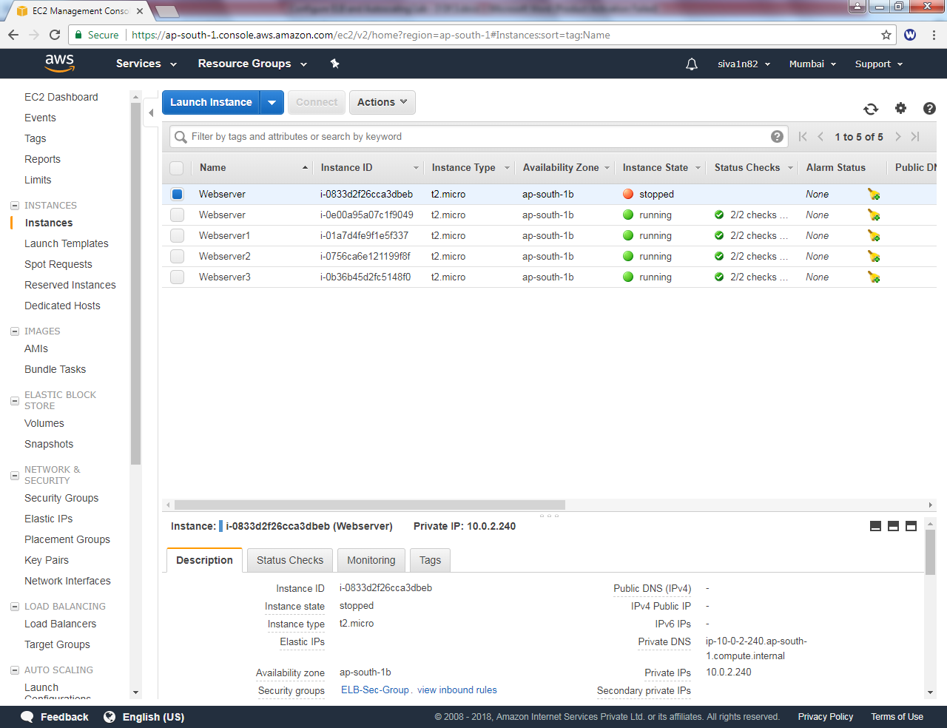

Now it’s moved to shutting down state.

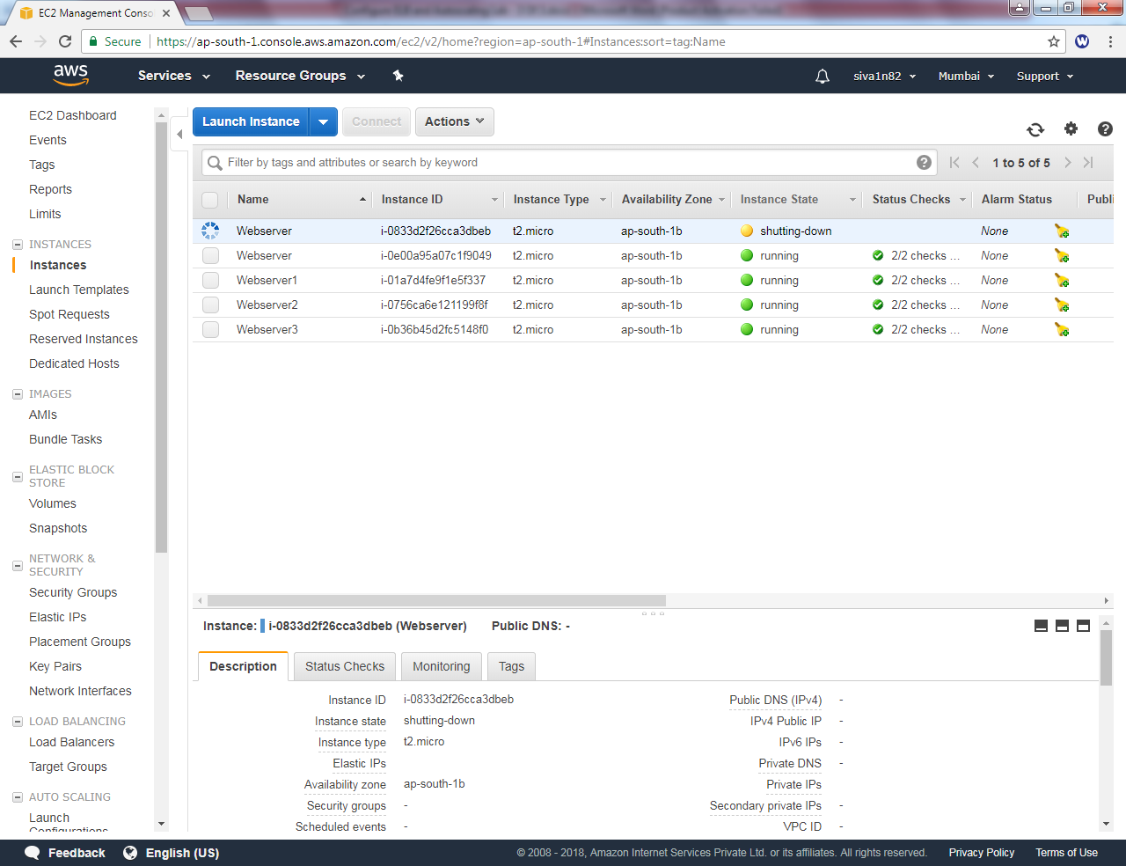

Now stopped instance has been terminated and creating new instance.

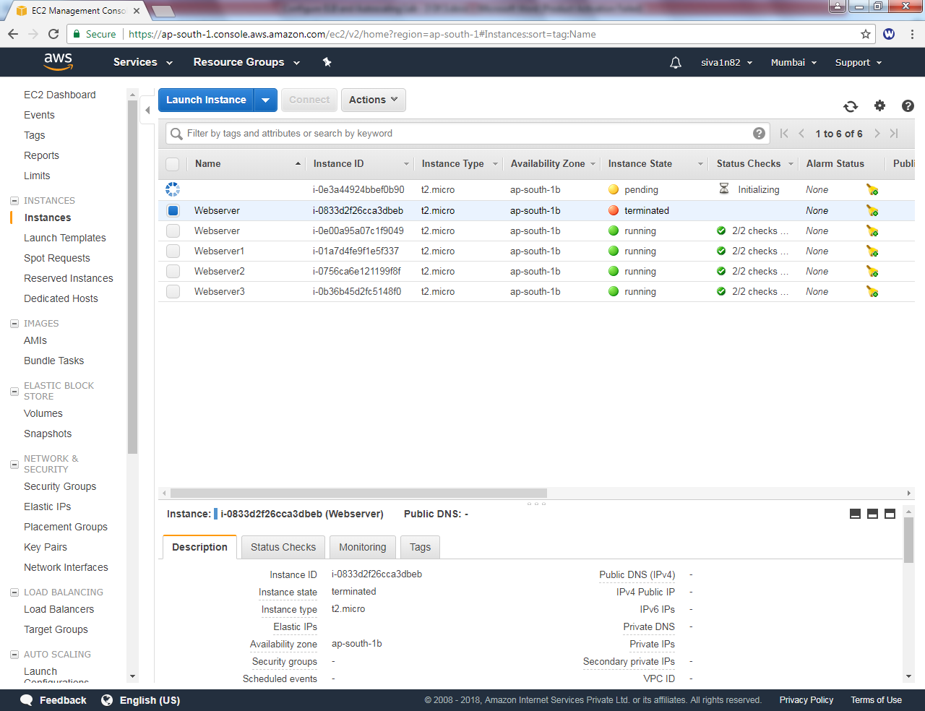

Now 2 instances in Autoscaling group and other 3 instances member of Loadbalancer is up.

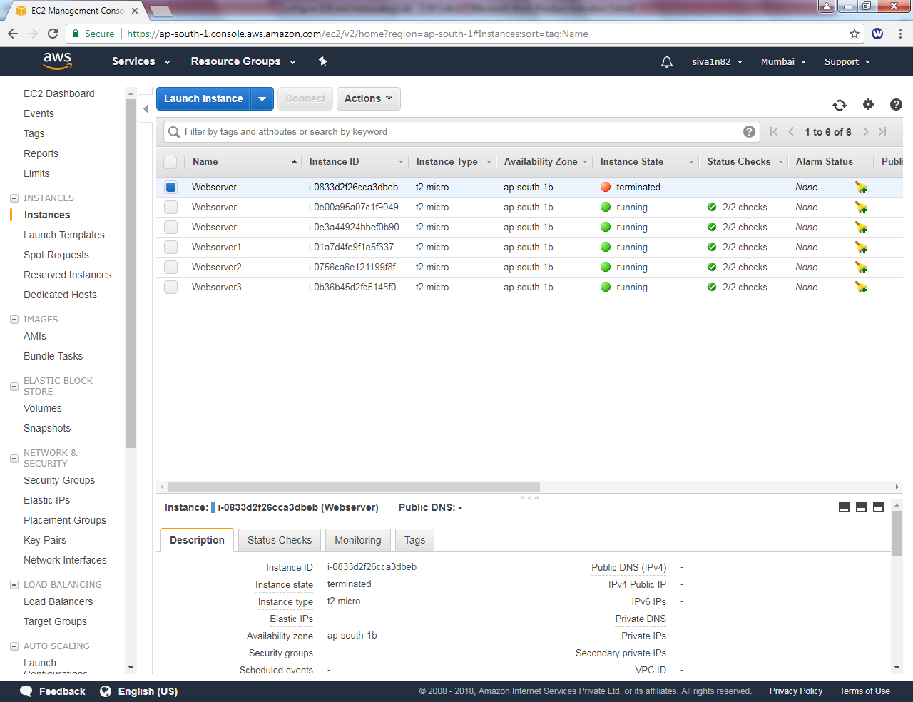

Click “Edit Instances”

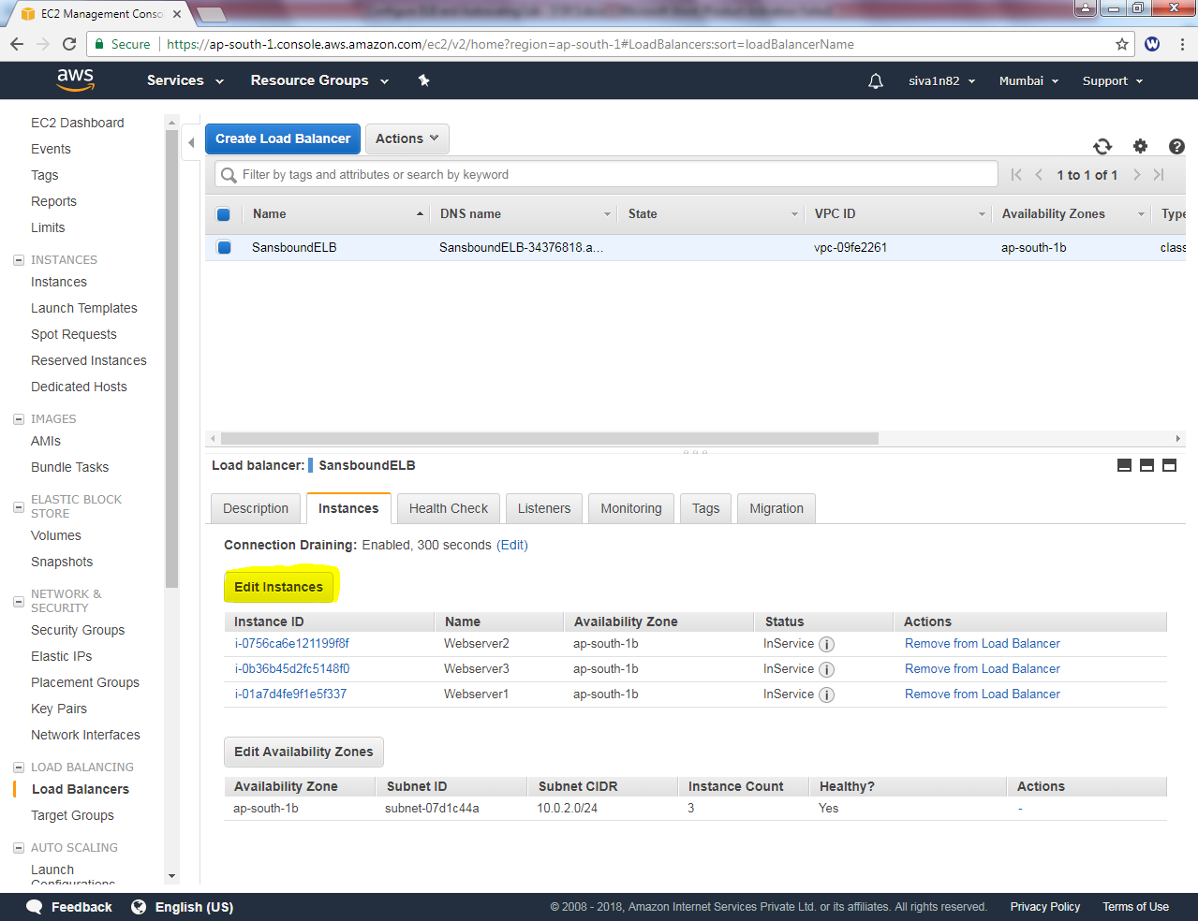

Need to add remaining two instances into Loadbalancer.

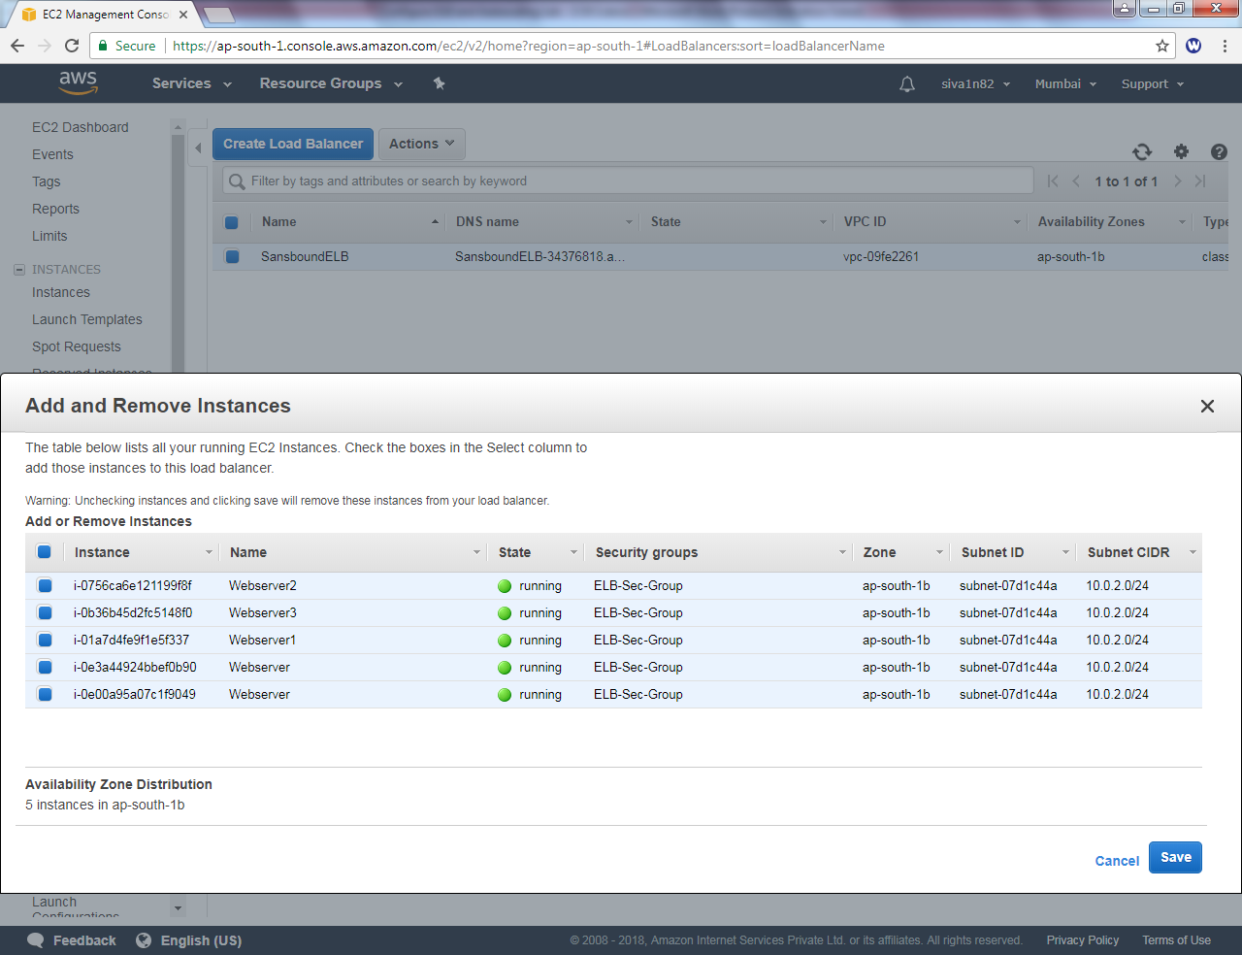

Click “Save”. Wait for 1-2 minutes to refresh the session. If exact output not comes please fresh the browser until the output comes. After that you will get output.

Webserver1



Webserver1



Webserver1



Webserver3



Webserver2

